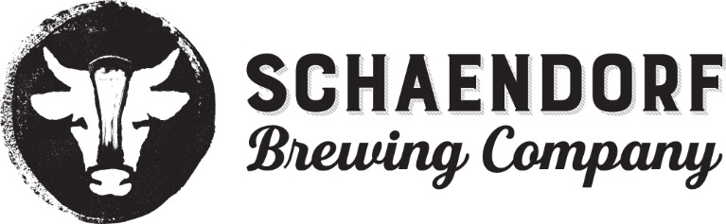

SCHAENDORF BREWING COMPANY SPONSORSHIP REQUEST

Thank you for considering Schaendorf Brewing as a sponsor! Groups must apply for donations using the form below and will be chosen based on available funds and alignment with our company’s goals.

Before you complete our application, below is information to keep in mind. Any donation requests submitted with less than 4 weeks’ notice will be omitted automatically.

Due to Michigan state law, we cannot donate beer. Please fill out this form entirely. We receive several submissions weekly and want to make sure we get all the crucial information needed to make an informed decision.

If you want to send more information not included on the form below, please email communications coordinator Nicole Heslip at nicolemheslip@gmail.com.

Contact Name:

Contact Email:

Contact Phone Number:

Name of Organization or group requesting:

Organization Website:

What is the organization's mission statement and purpose?

Is the organization a non-profit?
Event Start Date:
Event End Date:

Tell us about your event. (The more details you can share, the better!)

Where is your event's location?

Why do you think Schaendorf Brewing is a good fit for your organization?

What type of donation are you interested in?

Please let us know the dollar amount of your ideal in-kind donation.

How many people are expected to attend your event?

How many years has this event been held?

What sponsorship benefits are included in your proposal? We recognize that these benefits will change based on the level of sponsorship. If this applies for your opportunity, please include details here or in an attached document.

Are there any important deadlines we should know about?

Are there other details or thoughts we need to know?

